Chameleon

**Company Objectives & Structure**

Company Project Update

Task 6.2P

Company Structure

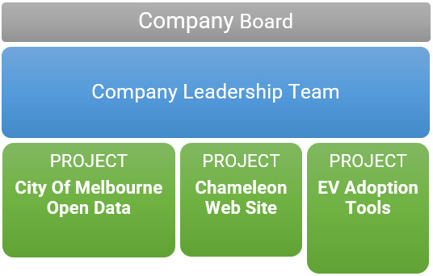

T1 2022 Objectives

* Establish a website presence for Chameleon
* Research, design and develop minimum viable products (MVP) for commercially viable EV Adoption Tools
* Enhance the Melbourne Open Data Playground to support City of Melbourne's smart cities goals and aspirations

Executive Summary

OUR MISSION

"Given the complexity of energy application needs today, IoT systems are being designed to address a wide variety of existing problems.

In Chameleon, our mission is to research, create, test, document and deploy IoT-based solutions to enhance life through the application of smart city technologies including: the building of smarter cities, homes, transportation, and energy management systems."

There are 3 divisions within the company, focusing on the 3 key areas of strategic importance:

* City of Melbourne Open Data
* Chameleon Website
* Electric Vehicle (EV) Adoption Tools

Both the open data project and the EV adoption tools leverage data sets that are created using IoT-based sensors and as such, fit into the goals of the company. The Chameleon website articulates the goals of the company and provides a visible presence.

The goals of the City of Melbourne Open Playground are to create a toolset to assist non-technical users in understanding some of the challenges that open data in the City of Melbourne can help to solve, along with useful, step by step examples.

The EV adoption tools division will be focusing on 3 projects. These projects will all related to building out tools to help drive EV adoption and/ or solve challenges associated with building out EV infrastructure.

____________________

Valeh Moghaddam

Director

Table of Contents

Leadership Team 1

Trimester Goals and Objectives 1

Company Structure and Projects Overview 1

Project 1: City of Melbourne Open Data 3

Overview, Goals, and Objectives 3

Aims for Trimester 3

Deliverables 3

Project Members 3

Project 2: Chameleon Website 4

Overview, Goals, and Objectives 4

Aims for Trimester 4

Deliverables 4

Project Members 4

Project 3: EV Adoption Tools 5

Overview, Goals, and Objectives 5

Aims for Trimester 5

Deliverables 5

Project Members 5

Sub-Project/Deliverable 1: Locate a Socket 6

Sub-Project/Deliverable 2: Identify Best EV Locations based on Big Data 6

# Leadership Team

The company board consists of the following key personnel:

* Valeh Moghaddam
* Chathu Ranaweera
* Seng Loke

Valeh Moghaddam is the acting director and key point of contact for the leadership team on a day-to-day basis.

The leadership team consists of the students:

|  |  |  |  |  |  |  |
| --- | --- | --- | --- | --- | --- | --- |
| **Student ID** | **Full Name** | **Junior/Senior** | **UG/PG** | **Team Group/Role** | **Project/Team Lead?** | **Project** |
| **221310579** | **Angela Corriero** | **Junior** | **Postgrad** | **Leadership Support** |  | **Chameleon** |
| **220622865** | **Van Tri Nguyen** | **Senior** | **Undergrad** | **Leadership Support** |  | **Chameleon** |
| **220544661** | **Glenn Richmond** | **Senior** | **Postgrad** | **Project Leader** | **Y** | **EV Adoption Tools** |
| **220618314** | **Nabil Francis** | **Senior** | **Postgrad** | **Project Leader** | **Y** | **Chameleon Website** |
| **220541733** | **Steven James Tuften** | **Senior** | **Postgrad** | **Project Leader** | **Y** | **City Of Melbourne Open Data** |

# Trimester Goals and Objectives

* Create an initial version of the Chameleon company website
* Implement additional use cases and perform a cloud platform migration for City of Melbourne Open Data Project
* Establish the framework, development processes, DevOps and possibly an early MVP for the mobile app
* Provide an initial MVP for the EV business case portal
* Perform initial research and create an early MVP for the EV location recommendation engine

# 6.2 Progress Update Summary

# Company Structure and Projects Overview

In our first trimester, Chameleon will be running the following three concurrent projects that, together, support the mission and objectives of the company.

* City of Melbourne Open Data – Promoting smart cities open data adoption
* Chameleon Web Site – A platform for showcasing and promoting Chameleon's activities
* EV Adoption Tools – A variety of tools to support the adoption of EV adoption by the Australian community

Chameleon is run by a Company leadership team comprising one Board Director and a student leadership team. This team coordinates whole of company initiatives and ensures projects are delivering on the company mission and objectives. The Company Leadership team reports to the Board of Directors.

Some members of the Student Leadership team are allocated as leaders of each of the projects with the remaining student leaders providing vitally important administrative and executive support functions for the company.

Figure 1 illustrates the company structure at a high level with members of each team listed in subsequent sections of this document and Figure 2 illustrates the typical structure of a project team its relationship to the Leadership team.

Each project may be comprised of multiple teams providing a different set of skills in support of the project's deliverables. Each team will have a designated team leader accountable for that teams' deliverables.

The project leader will be supported by an assistant project leader who can assist with project management, team communications and meeting facilitation. Assistant project leaders and team leaders are also candidates for future leadership roles in the subsequent trimester.

*Figure 1: Chameleon Company Structure*

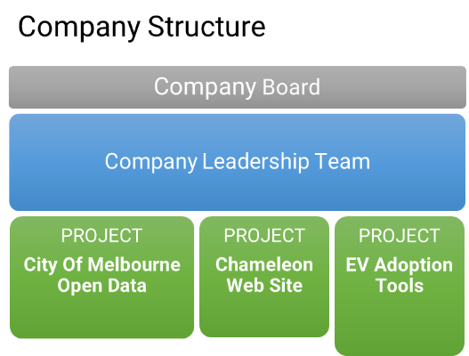

*Figure 2: Chameleon Project Team Structure*

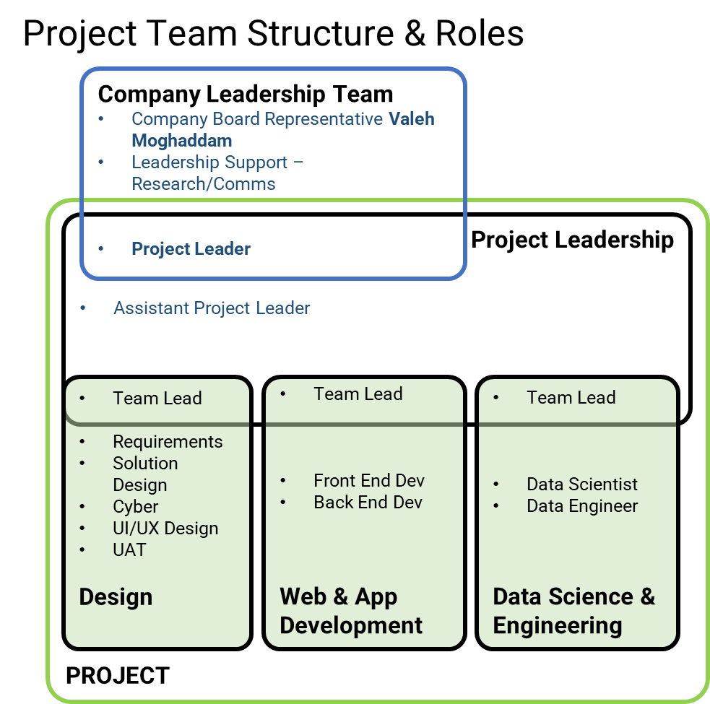

# Project 1: City of Melbourne Open Data

## Overview, Goals, and Objectives

The City of Melbourne has been an Australian leader in Open Data since 2014. The City of Melbourne initiated this project with Deakin to support greater use of their Open Data by businesses, researchers, and software developers. Open Data is a component of their smart cities' strategy.

This project delivers an education portal which demonstrates how to leverage Open Data using real world scenarios that may be of interest to industry, government, and researchers. Its long-term goal is to increase the usage of City of Melbourne Open Datasets and drive increased investment across the City of Melbourne council area.

## Aims for Trimester

This semester the project will aim to become integrated into the Chameleon project by re-focusing its deliverables on Smart Cities Open Data while delivering additional use cases of value to City of Melbourne businesses and residents.

## Deliverables

The short term (trimester) deliverable will be:

* Add additional data science use cases to the Melbourne Open Data Playground portal and GitHub Repo.
* Migrate the Melbourne Open Data Playground portal from AWS to Google Cloud Platform (GCP)
* Ensure the Melbourne Open Data Playground portal can run on mobile devices
* Make Minor cosmetic improvements to the Melbourne Open Data Playground portal

Longer term goals include:

* Preparing the Melbourne Open Data Playground portal and GitHub repository for use by the public
* Migrating the Pedestrian data use cases and Jupyter notebooks to support a new data provider
* Migrating the Open Data access API from SOCRATA to a new platform

## 6.2 Progress Update

Forecast of likely state of deliverables at end of trimester

Changes to original plan

New Projects added since 2.1P

## Project Members

|  |  |  |  |  |  |
| --- | --- | --- | --- | --- | --- |
| **Student ID** | **Full Name** | **Junior/Senior** | **UG/PG** | **Team Group/Role** | **Project/Team Lead?** |
| **220541733** | **Steven James Tuften** | **Senior** | **Postgrad** | **Project Leader** | **Y** |
| **217285498** | **Mollie Fernandez** | **Junior** | **Undergrad** | **Assistant Project Leader** | **Y** |
| **217495571** | **Alex V.A. Vuong** | **Senior** | **Postgrad** | **Data Science & Engineering** | **Y** |
| 220563849 | Mark Brooksby | Senior | Postgrad | Data Science & Engineering |  |
| 220532657 | Julian Cape | Junior | Postgrad | Data Science & Engineering |  |
| 400150369 | Bree Margaret McLennan | Junior | Postgrad | Data Science & Engineering |  |
| 221047172 | Nitish Kumar Neelala Harish | Junior | Postgrad | Data Science & Engineering |  |
| 220616385 | Brendan Patrick Richards | Junior | Postgrad | Data Science & Engineering |  |
| 221153273 | Anugra Sara Thomas | Senior | Postgrad | Data Science & Engineering |  |
| 215127684 | Ryan Daniel Waites | Junior | Undergrad | Data Science & Engineering |  |
| 221308586 | Pramodya Senanayaka | Junior | Postgrad | Data Science & Engineering |  |
| **217284769** | **Anthony Todaro** | **Senior** | **Undergrad** | **Design** | **Y** |
| 218271294 | Jacob Djaelani | Junior | Undergrad | Design |  |
| 218673691 | Imani Maina | Junior | Undergrad | Design |  |
| 218268634 | Harrison Corin Padraic Murphy | Junior | Undergrad | Design |  |
| 219362178 | Bansi Baiju Patel | Junior | Undergrad | Design |  |
| 217587577 | Kishen Makanji Patel | Senior | Undergrad | Design |  |
| 214335826 | Bradie Robinson | Senior | Postgrad | Design |  |
| **219302799** | **Janitha Thushara Nilaweera Patabandige** | **Junior** | **Postgrad** | **Web & App Development** | **Y** |
| 221023977 | Muhammad Sohaib Bin Kashif | Junior | Postgrad | Web & App Development |  |
| 219365506 | Lakshmi Meghana Kethiri | Senior | Postgrad | Web & App Development |  |
| 218296596 | Michael John Leen | Junior | Undergrad | Web & App Development |  |
| 218341765 | Shlomi Moreh | Junior | Postgrad | Web & App Development |  |
| 219273805 | Yi Yang (Eric) Yu | Junior | Undergrad | Web & App Development |  |
| 220614444 | Anno Gomes | Senior | Undergrad | Web & App Development |  |
| 221070031 | Tianqi Zhou | Junior | Postgrad | Web & App Development |  |
| 220236048 | Matthew Hall | Junior | Undergrad | Web & App Development |  |

# Project 2: Chameleon Website

## Overview, Goals, and Objectives

Like any other company, the Chameleon company requires a website to be its digital public facing space. The main goal of the website is to promote Chameleon’s projects, products, and the services that it provides. As the project implementation progresses additional features and functionalities will be added such as blogs, events calendar, and a clients’ area.

## Aims for Trimester

Being a new project that is built from scratch, the project team aims to deliver the infrastructure (Hosting environment, code repositories, deployment pipelines), the web development framework (SDLC process, Dev tools) and the handover document to be used in the future trimesters.

## Deliverables

This trimester's short-term deliverables include:

* Identify the hosting infrastructure and set up the DevOps pipelines
* Identify the web development tools and SDLC processes to follow
* Propose an initial website layout and style
* Include an initial list of standard pages (including links to other Chameleon projects) and start working on their contents

The future trimesters long term deliverables include:

* Finalise the list of pages
* Implement a SEO strategy to rank the website higher in the web search engines
* Implement a web tracking mechanism and a web traffic analysis
* Add a blogging engine
* Add an events calendar
* Add a clients’ area for project collaboration with various levels of user access

## 6.2 Progress Update

Forecast of likely state of deliverables at end of trimester

Changes to original plan

New Projects added since 2.1P

## Project Members

|  |  |  |  |  |  |
| --- | --- | --- | --- | --- | --- |
| **Student ID** | **Full Name** | **JuniorSenior** | **UG/PG** | **Team Group/Role** | **Project/Team Leader?** |
| **220618314** | **Nabil Francis** | **Senior** | **Postgrad** | **Project Leader** | **Y** |
| **217072092** | **Nykolai Garcia McHerron** | **Junior** | **Undergrad** | **Assistant Project Leader** | **Y** |
| **220077269** | **Ayushi Natalie Alujjage** | **Junior** | **Undergrad** | **Design** | **Y** |
| 221337514 | Nathan Cahill | Junior | PostGrad | Design |  |
| 220381653 | Jack Hagen | Junior | Undergrad | Design |  |
| 220490637 | Sangjun Kim | Junior | Undergrad | Design |  |
| 220102998 | Nikhil Nikhil | Junior | Undergrad | Design |  |
| 219204947 | Tejal Girish Ranade | Junior | Undergrad | Design |  |
| 218430879 | Paulina Katarzyna Wesolowska | Junior | Undergrad | Design |  |
| 220457523 | Zhenyu Ye | Junior | Undergrad | Design |  |
| 219449118 | Yinfei Zhou | Senior | Undergrad | Design |  |
| 220068066 | Uchechukwu Ajoku | Junior | Postgrad | Design |  |
| 216258809 | Karanbir Singh Bhatti | Senior | Undergrad | Design |  |
| **220599451** | **Ramanayake Arachchige Don Ruwanganath Ramanayake** | **Senior** | **Postgrad** | **Web & App Development** | **Y** |
| 219222529 | Lachlan James Exton | Junior | Undergrad | Web & App Development |  |
| 220460399 | Xinyu Ji | Junior | Undergrad | Web & App Development |  |
| 221418332 | Wensong Jing | Senior | Postgrad | Web & App Development |  |
| 219352504 | Bhavishya Pun | Junior | Undergrad | Web & App Development |  |
| 220240516 | Julian Ryan | Junior | Undergrad | Web & App Development |  |
| 220462328 | Kong Chenyu | Junior | Undergrad | Web & App Development |  |
| 217438109 | Dasun Kodikara M | Junior | Undergrad | Web & App Development |  |
| 218663803 | Surpeet Singh | Junior | Undergrad | Web & App Development |  |
| 218429514 | Shakwat Hossein Limon | Junior | Undergrad | Web & App Development |  |

# Project 3: EV Adoption Tools

## Overview, Goals, and Objectives

The EV Adoption Tools project aims to drive increased adoption of Electric Vehicles (EVs) in Australia.

This will help drive reduced dependence on fossil fuels, lower greenhouse gas emissions and have a positive impact on the environment and global weather events.

EV adoption tools will help EV owners better plan their trips by identifying optimal EV charging stations as waypoints on their journey.

The **Identify Best EV Locations based on Big Data** sub-project will support enterprises looking to establish charging stations in the optimal location based on user demand, traffic, EV owner density and many other data points sourced from government and industry.

## Aims for Trimester

The goals for this trimester will be:

* Set up the framework, development processes, DevOps, and possibly an early MVP, for the mobile app platform
* To provide an initial MVP for the EV Locate a Socket app
* To perform initial research and create an early MVP for the EV location recommendation engine

## Deliverables

This project has two deliverables running as sub-projects:

* Sub-Project/Deliverable 1: Locate a Socket
* Sub-Project/Deliverable 2: Identify Best EV Locations based on Big Data

## 6.2 Progress Update

Forecast of likely state of deliverables at end of trimester

Changes to original plan

New Projects added since 2.1P

All projects will require research, planning and design activities to be continued on this trimester with finalisation of each carried out in subsequent trimesters.

## Project Members

|  |  |  |  |  |  |
| --- | --- | --- | --- | --- | --- |
| **Student ID** | **Full Name** | **JuniorSenior** | **UG/PG** | **Team Group/Role** | **Project/Team Lead?** |
| **220544661** | **Glenn Richmond** | **Senior** | **Postgrad** | **Project Leader** | **Y** |
| **222084667** | **Mohamed Dallol** | **Junior** | **Postgrad** | **Assistant Project Leader** | **Y** |
| **216095588** | **Haley Holloway** | **Senior** | **Undergrad** | **Data Science & Engineering** | **Y** |
| 220267679 | Billie Jack Hancock | Junior | Undergrad | Data Science & Engineering |  |
| 219213881 | Matthew Robert Iredale | Junior | Undergrad | Data Science & Engineering |  |
| 221045868 | Rahul Kumar | Senior | Postgrad | Data Science & Engineering |  |
| 221430794 | Mei Liu | Junior | Postgrad | Data Science & Engineering |  |
| 218637524 | Disha Mann | Senior | Undergrad | Data Science & Engineering |  |
| 219605515 | Truong Giang Nguyen | Junior | PostGrad | Data Science & Engineering |  |
| 221459705 | Nidhi Tapankumar Patel | Junior | Postgrad | Data Science & Engineering |  |
| 600022742 | Sarah Bullen | Senior | Postgrad | Data Science & Engineering |  |
| **219285112** | **Sarishti Sarishti** | **Senior** | **Undergrad** | **Design** | **Y** |
| 221212001 | Richard Adams | Junior | Undergrad | Design |  |
| 220252511 | Yuvraj Kapoor | Junior | Undergrad | Design |  |
| 220421563 | Nihaal Sachdev | Junior | Undergrad | Design |  |
| 218292859 | Samuel James Spice | Junior | Undergrad | Design |  |
| **219020285** | **Harleen Kaur** | **Senior** | **Undergrad** | **Web & App Development** | **Y** |
| 222057256 | Kussay Al-Zubaidi | Junior | PostGrad | Web & App Development |  |
| 219051815 | Muhammad Ahmed Arif | Junior | Postgrad | Web & App Development |  |
| 220462328 | Chenyu Kong | Junior | Undergrad | Web & App Development |  |
| 219179817 | Hamish Glover | Junior | Undergrad | Web & App Development |  |
| 218062706 | Muhammad Rehan Qureshi | Junior | Undergrad | Web & App Development |  |
| 219314678 | Abhiishekh Avula | Senior | Undergrad | Web & App Development |  |

## Sub-Project/Deliverable 1: Locate a Socket

### Summary

The goal of this project is to be able to design and implement a mobile app (Android and IOS) to help consumers identify a nearby charging location. While there are existing apps on the market that offer this functionality (i.e., Chargefox), we believe that we can offer an app that differentiates itself from those apps by designing features that add value beyond just finding the charging station.

A few examples of what the app may offer in addition to the core function of locating a stock include:

* Providing additional information and filtering of stations based on type (EV vs hydrogen, for example), information on the source of the power (direct solar, grid powered, gas, diesel etc)
* Providing a full journey planner for longer trips that optimizes for reducing charge time, cost, and environmental impact along the route
* Ability to incorporate your usage data with current fuel prices, cost of maintenance etc and provide an indication of real savings for running the vehicle

Note that Chargefox does also offer the ability to pay for charging via the app, so this may be something to consider in the architecture of the platform.

### Aims for Trimester

The goal for this trimester will be:

* To create branding and user experience for the mobile app
* To create the process for capturing and processing updated EV location data
* To create an MVP mobile app that helps end users to identify nearby EV locations
* To be able to deploy this app on Android at a minimum
* To create the back-end framework to capture the EV location data

## 6.2 Progress Update

Forecast of likely state of deliverables at end of trimester

Changes to original plan

New Projects added since 2.1P

## Sub-Project/Deliverable 2: Identify Best EV Locations based on Big Data

### Summary

The goal of this sub-project is to use community data (population, traffic, transit etc) to predict where would be the most mutually beneficial place to install new charging stations so that:

* Stations are well located in relation to other charging stations
* People have other reasons to stop there (landmark or facility that people spend time at)
* Residents benefit from the installation (business see increased foot traffic & residents are spared extra traffic)
* Existing or planned infrastructure can accommodate the stations (power requirements)

This project will primarily be a data science project that will include:

* Identifying data sets that can support this decision-making process. This will include a research process that will determine whether the required data sets are available
* The outcomes here will be creating a dashboard and possibly an application or machine learning model that provides these recommendations

## 6.2 Progress Update

Forecast of likely state of deliverables at end of trimester

Changes to original plan

New Projects added since 2.1P